Effects of Spanish Rule in Florida
Grade 4
The following question is based on the accompanying documents (1-5). It is designed to test your ability to examine and interpret the meaning of the documents. Then you will write a final essay which uses important information from the documents you have analyzed.
Historical Background:
In 1492, Christopher Columbus sailed across the Atlantic Ocean from Europe and landed in the Americas. By the 1600s, the Spanish, British, French, and Dutch had explored the Atlantic Coast of what is now the United States. Spain claimed Florida in 1513 and ruled it for over 280 years. There were many effects of Spanish colonial rule in Florida.
Task:
For Part A, read each document carefully and answer the question or questions after each document. Then read the directions for Part B and write your essay.
For Part B, use your answers from Part A, information from the documents, and your knowledge of social studies to write a well-organized essay. In the essay you should:
Discuss the effects of Spanish rule in Florida.
Directions:

- Read the task. Do you understand it?
- Ask yourself: “What do I already know about the Spanish arrival, exploration, and colonization of Florida? How would I answer the question, even if I could not look at the documents?”
- Now look at the documents. Study each one and highlight any information that will help you answer the question. Ask yourself: “How does this help me to answer the question?”
- Each document is followed by a question(s). Write an answer to each of these questions in the blank that follows it.
- When you are finished studying all the documents, go on to Part B. Follow the directions and write your essay.

Document 1:
Since waterways were important highways in colonial times, many of the first settlements were established on coasts.
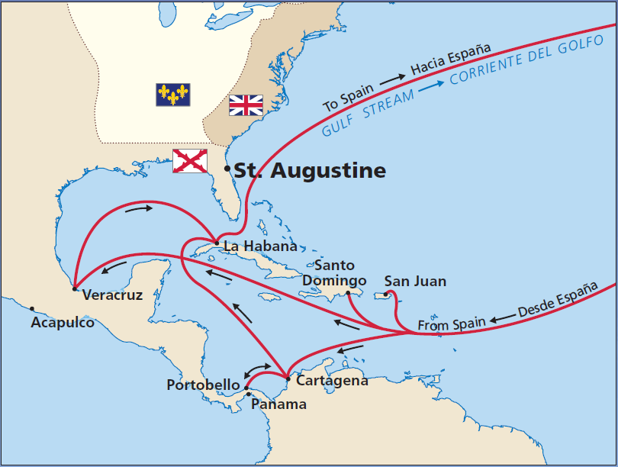
Source: National Park Service

- According to the document, what settlement did the Spanish establish in Florida?

Document 2:
The following was written in 1565 when the Spanish arrived in St. Augustine, Florida.
“On Saturday, the 8th, the general (Pedro Menéndez de Avilés) landed… marched up to the cross, followed by all who accompanied him, and there they kneeled and embraced the cross. A large number of Indians watched these proceedings and imitated all they saw done…
On Monday, September 24th... we saw a man approaching with loud cries. I was the first to run to him and get the news. He embraced me with transport, crying, "Victory! Victory! the French fort is ours!"
Source: Francisco Lopez de Mendoza Grajalas: The Founding of St. Augustine, 1565 (adapted)

- Based on the document’s source, who’s point of view is this?

- Based on the document, describe one result of the Spanish arrival in St. Augustine, Florida.

Document 3:

There were nine earthen and wooden forts in St. Augustine before a stone fort was built.
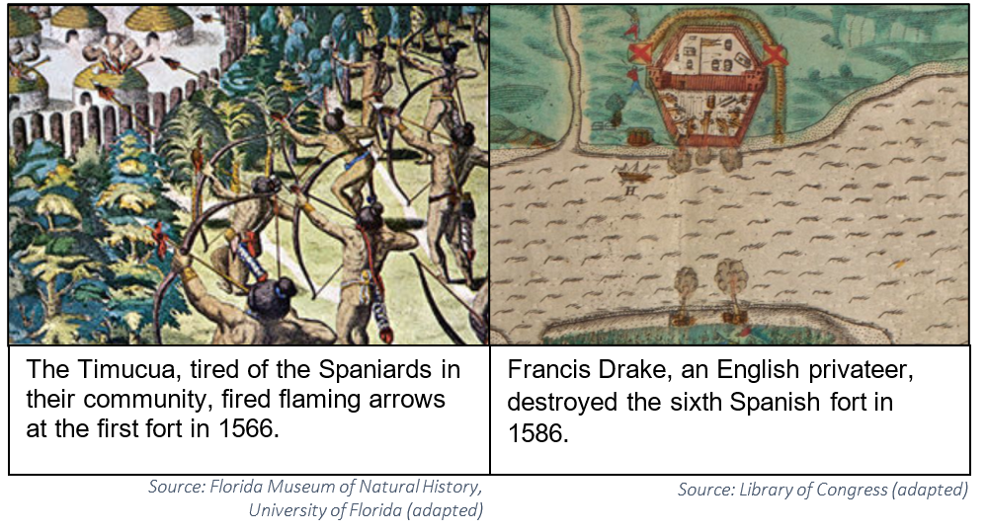

- Based on the documents, describe one conflict or problem the Spanish encountered.

Document 4:
Spaniards, free and enslaved Africans, European prisoners, and Timucua, Apalachee, and Guale natives built the Castillo de San Marcos out of coquina stone in 1672-1695. Although it has been attacked several times, the fort has never been destroyed or defeated.
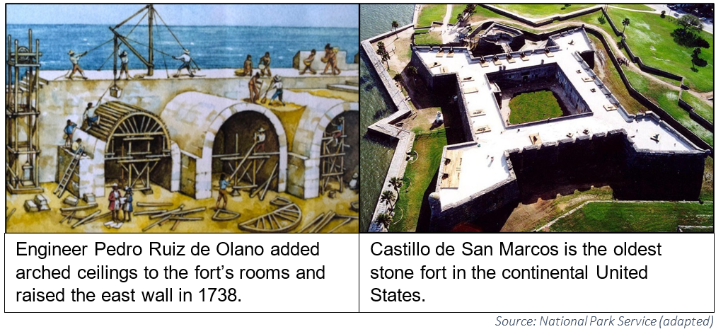
- Based on these documents, who built the Castillo de San Marcos?

- Based on these documents, why is the Castillo de San Marcos important?

Document 5:

The population in 1763 in St. Augustine, Florida.
Class | Population
Soldiers and their families | 1,916
Catalan fusiliers (soldiers who use flintlock muskets) and their families | 161
Canary Island families | 425
German Catholic families | 26
Christian Native Americans | 89
Free people of African ancestry | 23
Free people of mixed ancestry (European, African, Native American) | 76
Enslaved people of African ancestry | 309
Convict laborers | 38
TOTAL | 3,063
Source: Florida Museum of Natural History, University of Florida

- Based on the document, what was the total population in St. Augustine in 1763?

- Based on the document, were the people of St. Augustine diverse? Justify your answer using the information from the chart.

Part B:
Directions: Using the documents, your answers to the questions in Part A, and your knowledge of social studies, write a well-organized essay about the effects or results of Spanish rule in Florida during the colonial period.

In your essay, remember to:
- Discuss the effects of Spanish rule in Florida.
- Include an introduction, body, and a conclusion.
- Include details, examples, or reasons to develop your ideas.
- Use specific details from at least three documents in Part A.
- Develop your essay using correct grammar, punctuation, and spelling.

